Great New Books at Van Tech Tech

**Leviathan**, by Scott Westerfeld

Fifteen-year-old Austrian Prince Alek, on the run from the Clanker Powers who are attempting to take over the globe using mechanical machinery, forms an uneasy alliance with Deryn who, disguised as a boy to join the British Air Service, is learning to fly genetically-engineered beasts. An action packed steampunk novel: a mixture of alternate history crossed with science fiction. Winner of the 2010 Locus Award for Best Young Adult Fiction.

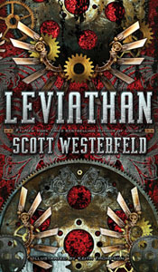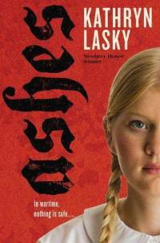

**Uglies**, by Scott Westerfeld

Just before their sixteenth birthdays, when they will be transformed into beauties whose only job is to have a great time, Tally's best friend runs away and Tally must find her and turn her in, or never become pretty at all. A suspenseful science fiction novel of friendship and personal discovery.

**Ashes**, by Kathryn Lasky

In 1932 Berlin, thirteen-year-old Gaby Schramm witnesses the beginning of Hitler's rise to power, as soldiers become ubiquitous, her beloved literature teacher starts wearing a jeweled swastika pin, and the family's dear friend, Albert Einstein, leaves the country while Gaby's parents secretly bury his books and papers in their small yard. Ashes is a breath-taking story of historical fiction.

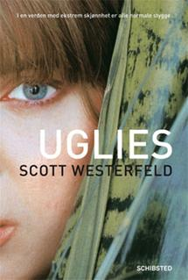

**Waves,** by Sharon Dogar

Fifteen-year-old Hal found his sister Charley washed up on a Cornwall beach, unconscious. A year later, as his parents wrestle with disconnecting Charley from life support, the family returns to Cornwall. Waves of Charley's thoughts and memories float eerily into Hal's mind, driving him to discover what happened to his sister. Waves is a suspenseful mystery novel with a heart.

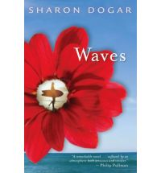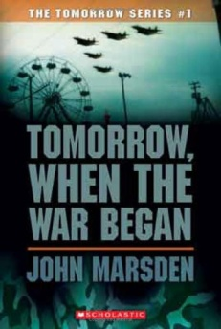

**Tomorrow When the War Began**, by John Marsden

Australian teenager Ellie and six of her friends return from a winter break camping trip to find their homes burned or deserted, their families imprisoned, and their country occupied by a foreign military force in league with a band of disaffected Australians. As their shock wears off, the seven decide they must stick together if they are to survive. A fast-paced and provocative novel of adventure.

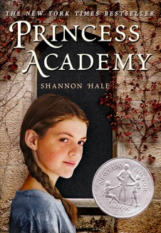

**Princess Academy,** by Shannon Hale

While attending a strict academy for potential princesses with the other girls from her mountain village, fourteen-year-old Miri discovers unexpected talents, abilities and connections to her homeland. This is an unexpected fantasy coming of age novel. Winner of the Newberry Award.

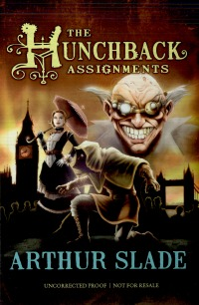

**The Everafter**, by Amy Huntley

Madison Stanton doesn't know where she is or how she got there. But she does know this—she is dead. And alone, in a vast, dark space. The only company she has in this place are luminescent objects that turn out to be all the things Maddy lost while she was alive. And soon she discovers that with these artifacts, she can reexperience—and sometimes even change—moments from her life.

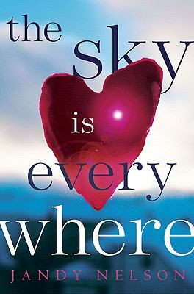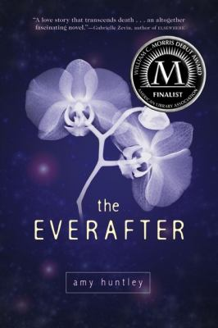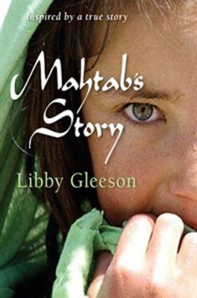

**Life as We Knew It,** by Susan Beth Pfeffer

Mahtab and her family are forced to leave their home in Herat and journey secretly through rocky mountains to Pakistan and from there to faraway Australia. Months go by, months of waiting, months of dread. Will they ever be reunited with their father, will they ever find a home? The plight of refugees from war-torn countries and what it really means to leave everything behind.

**Sky is Everywhere**, by Jandy Nelson

In the months after her sister dies, seventeen-year-old Lennie falls into a love triangle and discovers the strength to follow her dream of becoming a musician. This is an emotional and humorous story of death, recovery and hope.

**Life as We Knew It,** by Susan Beth Pfeffer

Through journal entries sixteen-year-old Miranda describes her family's struggle to survive after a meteor hits the moon, causing worldwide tsunamis, earthquakes, and volcanic eruptions. A gripping novel that portays the frustration and fear of the situation and the tenderness that grows from working together to survive.

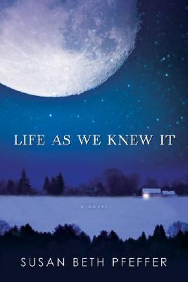

**I Kissed a Zombie and I Liked it**, by Adam Selzer

Living in the post-human era when the undead are part of everyday life, high schooler Alley breaks her no-dating rule when Doug catches her eye, but classmate Will demands to turn her into a vampire and her zombie boyfriend may be unable to stop him. This is a supernatural story of love and betrayal.



**The Hunchback Assignments,** by Arthur Slade

When Mr. Socrates, a member of the shadowy Permanent Association, hears of a hunchbacked infant with the ability to transform his appearance, he decides to take him in. Naming him Modo, he raises the boy in isolation, training him to become a secret agent. Then, when Modo turns fourteen, he is transported to the streets of downtown London and abandoned, penniless, to try to survive.

**Slot Machine**, by Chris Lynch

This darkly funny look at growing up male in America is narrated by chubby, 14-year-old Elvin Bishop, who describes, with sublime sarcasm, his increasingly painful efforts to find his appropriate athletic "slot."

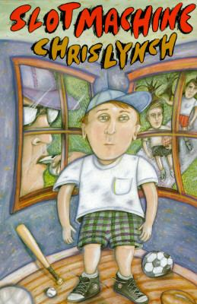

**Fallen**, by Kate Lauren

Suspected in the death of her boyfriend, seventeen-year-old Luce is sent to a Savannah, Georgia, reform school where she meets two intriguing boys and learns the truth about the strange shadows that have always haunted her. Dangerously exciting and darkly romantic, this workis a page turning thriller and the ultimate love story.

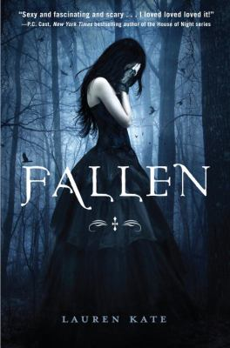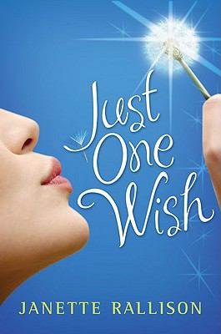

**Just One Wish,** by Jeanette Rallison

Seventeen-year-old Annika tries to cheer up her little brother Jeremy before his surgery to remove a cancerous tumor by bringing home his favorite television actor, Steve Raleigh, the star of "Teen Robin Hood." It’s a laugh-out-loud story of romance and deep-hearted storytelling.

**Maze Runner**, by James Dashner

Sixteen-year-old Thomas wakes up with no memory in the middle of a maze and and realizes he must work with the community in which he finds himself if he is to escape. Maze Runner is an action-packed science fiction novel of survival.

**Damosel,** by Stephanie Spinner

Damosel, a rule-bound Lady of the Lake, and Twixt, a seventeen-year-old dwarf, relate their experiences as they strive to help King Arthur face Morgause, Morgan, and Mordred, one through her magic and the other through his humble loyalty. Damosel is an exciting twist on the classic tales of King Artur.

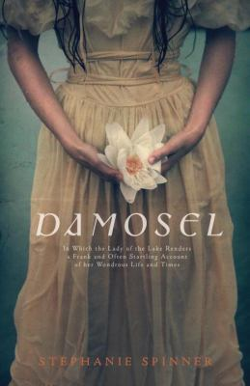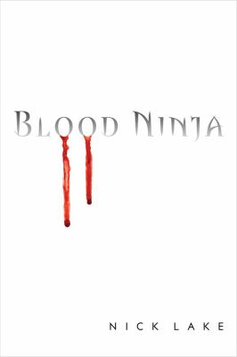

**Blood Ninja**, by Nick Lake

After his father is murdered and a ninja saves his life, Taro discovers the connection between ninjas and vampires and finds himself being dragged into a bitter conflict between the rival lords ruling Japan. This is a fast-paced and gripping fantasy story of an unlikely hero.

**All That Lives Must Die,** by Eric Nylund

Twins Eliot and Fiona Post, children of the goddess Atropos and the fallen angel Lucifer, face their toughest ordeal yet--high school at the Paxington Institute, where magic wielders learn to harness their powers. It is an urban fantasy book of good vs. evil.

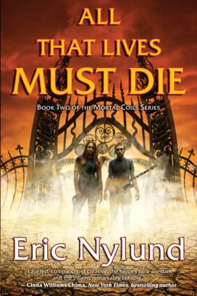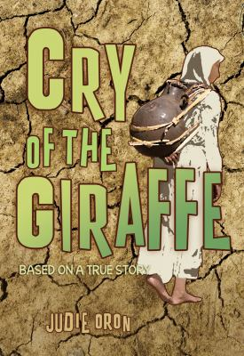

**Cry of the Giraffe**, by Judie Oron

Labeled outcasts by their Ethiopian neighbors because of their Jewish faith, Wudita and her family make the arduous trek on foot to Sudan in the hope of the promise of a better life. Instead, they are herded into a squalid refugee camp. Wudita becomes separated from her family and forced back to the Ethiopian border.

**The Iron King,** by Julie Kagawa

Something has always felt slightly off in Meghan's life, ever since her father disappeared before her eyes when she was six. When a dark stranger begins watching her from afar, and her prankster best friend becomes strangely protective of her, Meghan senses that everything she's known is about to change. But she could never have guessed the truth, or that she would become an important part of a mystical war.

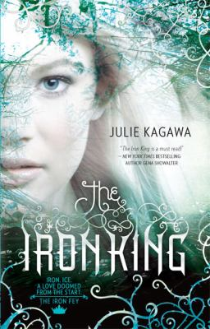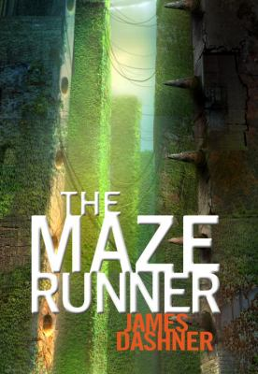

**Ancient, Strange and Lovely,** by Susan Fletcher

In a slightly futuristic, polluted world, fourteen-year-old Bryn watches an ancient egg hatch, and her life changes forever when she realizes that the critter is really a dragon. When the dracling becomes an Internet phenomenon, she must flee to protect him from poachers and others who wish him harm. This is a fast-passed scientific fantasy adventure.

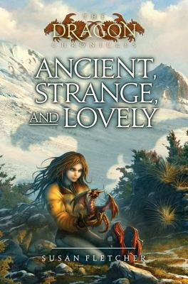

**Here Lies Arthur**, by Philip Reeve

Everyone's heard of King Arthur, but no one's ever heard the truth. When her village is attacked and burned, Gwyna seeks protection from the bard Myrddin, who uses Gwyna in his plan to transform young Arthur into the heroic King Arthur. This is a clever and adventurous twist on the classic tale of King Arthur.

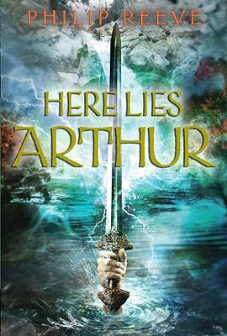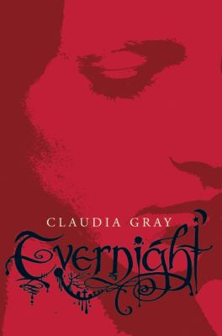

**Evernight,** by Claudia Gray

Sixteen-year-old Bianca, a new girl at the sinister Evernight boarding school, finds herself drawn to another outsider, Jared, but dark forces threaten to tear them apart and destroy Bianca's entire world. This is a supernatural love story with thrilling dramatic twists.

**Numbers**, by Rachel Ward

Fifteen-year-old Jem knows when she looks at someone the exact date they will die, so she avoids relationships and tries to keep out of the way, but when she meets a boy named Spider and they plan a day out together, they become more involved than either of them had planned. Jem foresees a chilling chain of events. The city's a target. The clock's running out. The countdown is on to a blowup, and her world is about to explode!

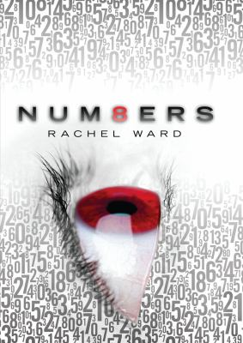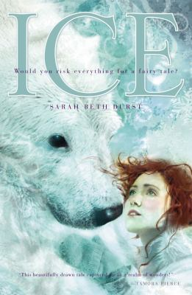

**Ice,** by Sarah Durst

A modern-day supernatural retelling of "East o' the Sun, West o' the Moon" in which eighteen-year-old Cassie learns that her grandmother's fairy tale is true when a Polar Bear King comes to claim her for his bride and she must decide whether to go with him and save her long-lost mother, or continue helping her father with his research.

**If You Live Like Me**, by Lori Weber

Cheryl's unhappiness builds with each move as her family travels across Canada while her father does research for a book, and by the time they reach Newfoundland, she is planning her escape, but events cause her to re-examine her feelings. This work of fiction explores the bonds that form in strange and unexpected ways, and shows how letting go can lead to the strongest connections of all.



**Things I Know About Love**, by Kate Le Vann

Seventeen-year-old Livia Stowe travels from England to Princeton, New Jersey, to visit her brother who is studying there and to celebrate her recovery from a year-long struggle with leukemia, and while she is there she writes a blog about her experiences, which include falling in love.

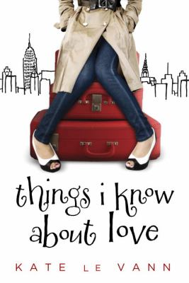

**The Scorpio Races** by Maggie Stiefvater

The waters around the rocky island of Thisby are inhabited by terrifying meat-eating water horses. Each November the boldest of Thisby’s residents ride these creatures in the Scorpio Races. The winner of these races will achieve fortune, wealth and fame. Many of the losers will not survive the ride. Will the bond formed between racers Kate Connolley and Sean Kendrick help them to survive?

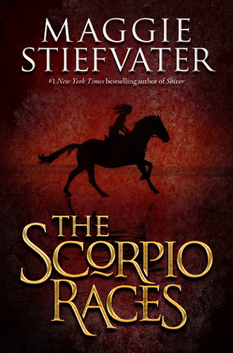

**Across the Universe** by Beth Revis

Teenaged Amy, a cryogenically frozen passenger on the spaceship Godspeed, wakes up to discover that someone may have tried to murder her.

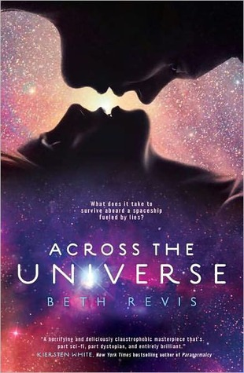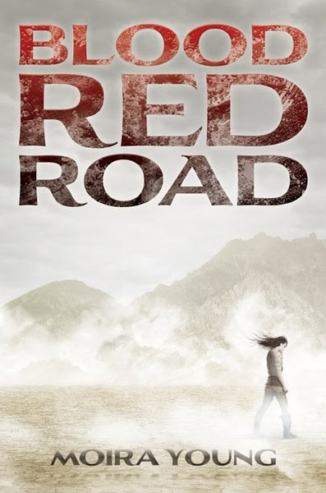

**All These Things I’ve Done** by Gabrielle Zevin

In a future where chocolate and caffeine are contraband, teenage cellphone use is illegal, and water and paper are carefully rationed, sixteen-year-old Anya Balanchine finds herself thrust unwillingly into the spotlight as heir apparent to an important New York City crime family.

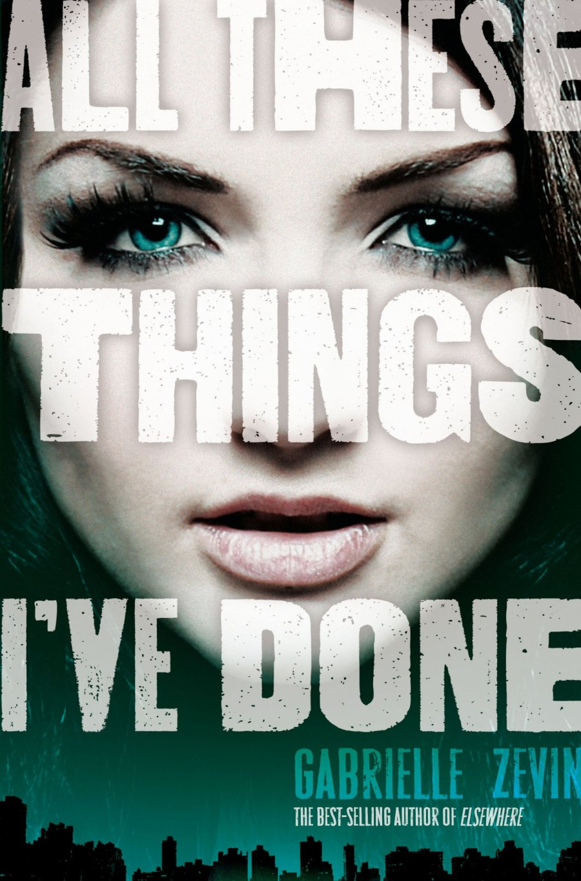

**Blood Red Road** by Moira Young

In a distant future, eighteen-year-old Lugh is kidnapped, and while his twin sister Saba and nine-year-old Emmi are trailing him across bleak Sandsea they are captured, too, and taken to brutal Hopetown, where Saba is forced to be a cage fighter until new friends help plan an escape.

**Dust City** by Robert Paul Weston

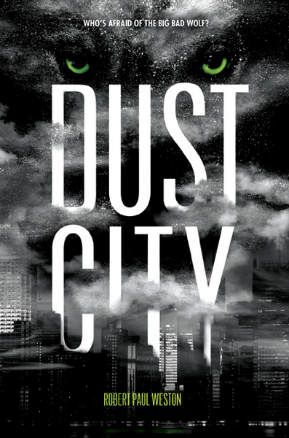

Henry Whelp, son of the Big Bad Wolf, investigates what happened to the fairies that used to protect humans and animalia, and what role the corporation that manufactures synthetic fairy dust played in his father's crime.

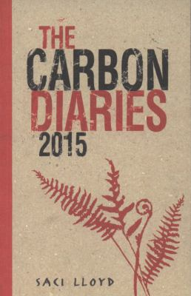

**Carbon Diaries 2015**, by Lloyd Saci

In 2015, when England becomes the first nation to introduce carbon dioxide rationing in a drastic bid to combat climate change, sixteen-year-old Laura documents the first year of rationing as her family spirals out of control. In these dark days, Laura deals with the issues that really matter: love, floods and pigs. This is a revealing science fiction story of environmental change.

**Big Game of Everything**, by Chris Lynch

In this humorous and revealing story, Jock and his eccentric family spend the summer working at Grampus's golf complex, where they end up learning the rules of "The Big Game of Everything.”

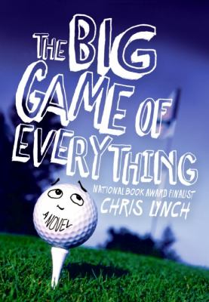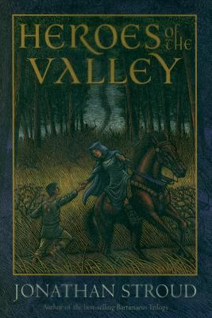

**Heroes of the Valley,** by Jonathan Stroud

In this funny and epic story, Halli becomes bored with his everyday life in a village where he doesn’t fit in. Halli can’t help himself from playing practical jokes on everyone. But one day he goes too far, setting in motion a chain of events that will forever alter his destiny. Along the way, he will encounter highway robbers, terrifying monsters, and a girl who may be as fearless as he is.

**Invention of Hugo Cabret**, by Hugo Cabret

When twelve-year-old Hugo, an orphan living and repairing clocks within the walls of a Paris train station in 1931, meets a mysterious toyseller and his goddaughter, his undercover life and his biggest secret are jeopardized. This is a suspenseful and mysterious novel of innovation and beauty.

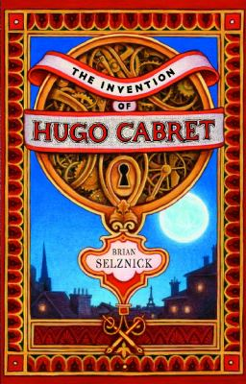

**Living Hell**, by Catherine Jinks

What happens when a single moment changes everything? For seventeen-year-old Cheney, life on earth exists only in history books. He and more than one thousand other people have known life only aboard the Plexus spacecraft: self-contained, systematic, and serene. But that was before the radiation wave.  In a suspenseful story full of gruesome characters, Cheney and his friends need to fight back before the ship that's nurtured them for so long becomes responsible for their destruction.

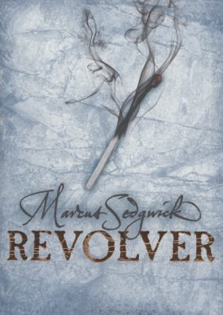

**Revolver,** by Marcus Sedgwick

In a suspenseful story set in the artic, fifteen-year-old Sig Andersson is alone, except for the corpse of his father, who died earlier that day after falling through a weak spot on the ice-covered lake. Then comes a knock at the door. It's a man with a gun and unfinished business with his father. When the man threatens his family, he needs to choose: Should he use his father’s gun, or not?

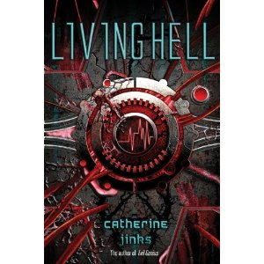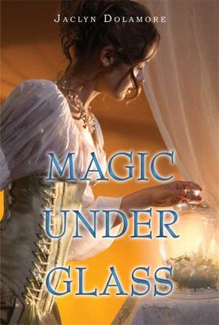

**Magic Under Glass,** by Jaclyn Dolamore

When a wealthy sorcerer hires Nimira to sing with a mysterious piano-playing automaton, Nimira believes it will be the start of a better life. But at the sorcerer's estate, rumors swirl about ghosts, a madwoman, and fairies that are tortured for sport. When Nimira discovers-and falls for-the spirit of a fairy gentleman trapped in the automaton, she will also find the fate of the magical world in her hands.

**Nation**, by Terry Pratchett

After a devastating tsunami destroys all that they have ever known, Mau, an island boy, and Daphne, an aristocratic English girl, together with a small band of refugees, set about rebuilding their community and all the things that are important in their lives in this story of survival and recovery.

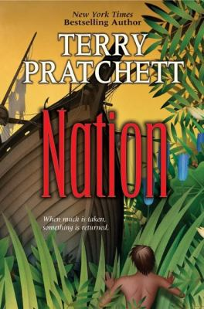

Z

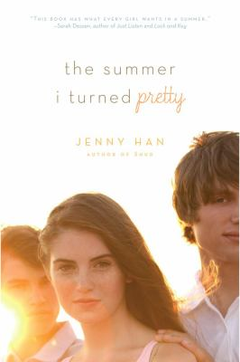

**The Summer I Turned Pretty,** by Jenny Han

In this coming of age story, Belly spends the summer she turns sixteen at the beach just like every other summer of her life. The boys never noticed Belly noticing them. And every summer she hoped it would be different. This time, it was. But the summer Belly turned pretty was the summer that changed everything. For better, and for worse.

**Once Was Lost**, by Sara Zarr

As the tragedy of a missing girl enfolds in her small town, fifteen-year-old Samara, who feels emotionally abandoned by her parents, begins to question her faith in this dramatic story of self-perception.

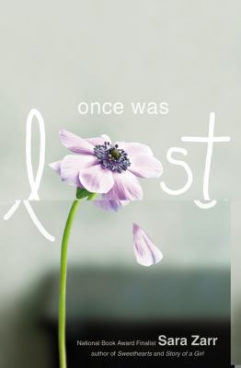

**First Shot,** by Walter Sorrells

As David enters his senior year of high school, a family secret emerges that could solve the mystery of why his mother was murdered two years ago. *First Short* is a thrilling mystery story of a boy looking for answers.

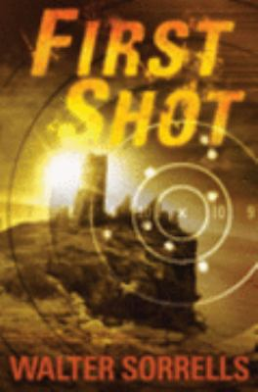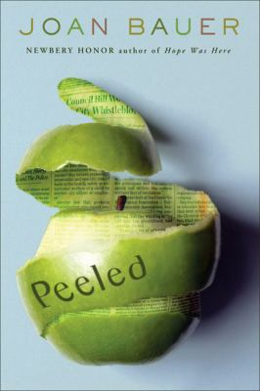

**Peeled**, by Joan Bauer

Hildy Biddle is a high school reporter eager to stand up for the truth. She's just waiting for a chance to prove herself as a journalist, and yearning for a big story. The trouble is, the town's biggest story stars... a ghost! Not an easy interview! Her efforts to find out who is really haunting Banesville isn't making her popular, and she starts wondering if she's cut out to be a journalist after all. But she refuses to give up, because, hopefully, the truth will set a few ghosts free.

**Into the Woods,** by Lyn Gardner

In this action-packed fantasy story, three sisters--Storm, the inheritor of a special musical pipe, the elder Aurora, and the baby Any—flee into the woods and begin a treacherous journey filled with many dangers as they try to find a way to defeat their pursuer and keep him from taking the pipe and control of the entire land.

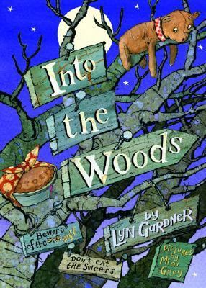

**The Declaration**, by Gemma Malley

In this science fiction story of a distant future, it is illegal to be young. Children are all but extinct. The world is a better place. Longevity drugs are a fountain of youth. Sign the Declaration, agree not to have children and you too can live forever. Refuse, and you will live as an outcast. Not everyone thinks Longevity is a good thing, but you better be clear what side you’re on.

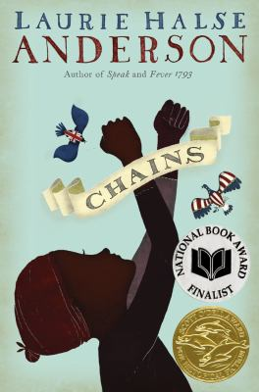

**Chains,** by Laurie Halse Anderson

After being sold to a cruel couple in New York City, a slave named Isabel spies for the rebels during the Revolutionary War. *Chains* is a compelling and impeccably researched novel that shows the lengths we can go to cast off our chains, both physical and spiritual.

**Interworld**, by Neil Gaiman

At nearly fifteen years of age, Joey Harker learns that he is a Walker, able to travel between dimensions, and soon joins a team of different versions of himself, each from another dimension, to fight the evil forces striving to conquer all the worlds. This science fiction novel is thrilling and gripping with action packed sequences.

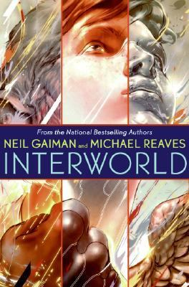

**Wintersmith, by Terry Pratchett**

When the God of Winter falls in love with 13-year-old apprentice witch Tiffany Aching. She enlists the support of the Wee Free Men--her toughest, craziest, and smallest friends--to protect her world from being eternally frozen. In this energetic mix of fantasy, humor, and uncommon common sense, Tiffany Aching discovers new meanings of magic.

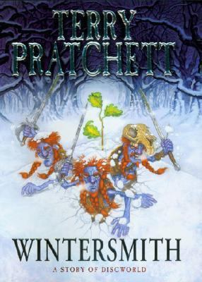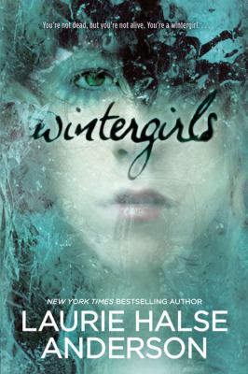

**Wintergirls,** by Laurie Halse Anderson

In this tale of guilt and death, Eighteen-year-old Lia comes to terms with her best friend's death from anorexia as she struggles with the same disorder. Lia is haunted by her friend's memory and racked with guilt for not being able to help save her.

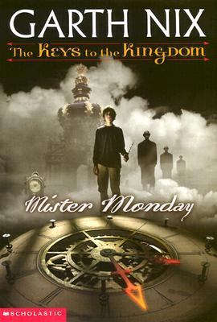

**Mister Monday**, by Garth Nix

During a running exercise at school, Arthur Penhaligon collapses from an asthma attack. Upon awakening, he meets a stranger, Mister Monday. Monday hands Arthur an unusual key which begins a wild adventure. Using the powers of the key, Arthur travels to another realm and battles many evil creatures in a struggle to save his world from a mysterious disease. There are several violent episodes, and the fast-moving and imaginative plot and strong characterizations capture listeners' attention.

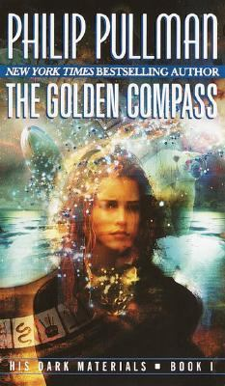

**The Golden Compass,** by Philip Pullman

In this epic fantasy adventure, Lyra Belacqua sets out to prevent her best friend and other kidnapped children from becoming the subject of gruesome experiments in the Far North. There is genuine terror in this book, and heartbreak, betrayal, and loss. There is also love, loyalty, and an abiding morality that infuses the story but never overwhelms it.

**So This is How It Ends (Avatars, Bk. 1)**, by Tui T. Sutherland

During an earthquake in the year 2012 five teens are transported seventy-five years into the future, where the end of the world is imminent, and are drawn together by a mysterious force. In this science fiction thriller, the teens must navigate world in which they seem to be the only normal humans left.

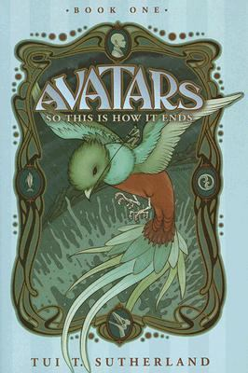

**I Conquer Britain,** by Dyan Sheldon

In this humorous story, sixteen-year-old Cherokee Salamanca is thrilled with the idea of visiting London. But when she swaps lives with British teenager Sophie Pitt-Turnbull, she gets more than she bargained for. Dealing with her London misadventures takes humour and determination; but, as her adopted family realize, you can take the girl out of Brooklyn, you can't take Brooklyn out of the girl!

**The Night Tourist, by Katherine Marsh**

After fourteen-year-old classics prodigy Jack Perdu has a near fatal accident he meets Euri, a young ghost who introduces him to New York's Underworld, where those who died in New York reside until they are ready to move on, and Jack vows to find his dead mother there.

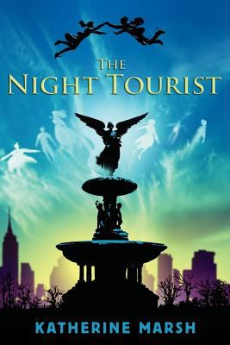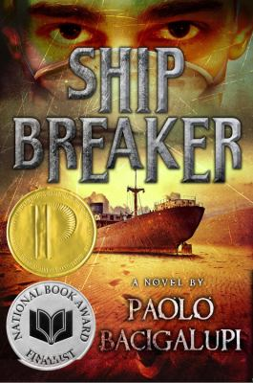

**Shipbreaker,** by Paolo Bacigalupi

In a futuristic world, teenaged Nailer scavenges copper wiring from grounded oil tankers for a living, but when he finds a beached clipper ship with a girl in the wreckage, he has to decide if he should strip the ship for its wealth or rescue the girl.

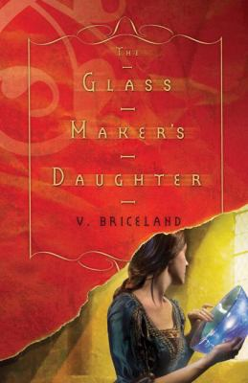

**Glassmaker’s Daughter, by V. Briceland**

Sixteen-year-old Risa's disappointment over an unprecedented event is devastating, but the evil and destruction that follows the king's death show her that the god and goddess have special need of her talents and those of her new, lower-class friends.

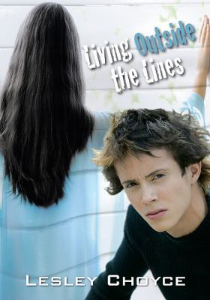

**Living Outside the Lines,** by Lesley Choyce

Nigel Lukes, 16, dreams about a better world and about becoming a great writer. His delight in his creative-writing class is almost as exciting as the romance that has blossomed between him and a new student, Michelle. For a class assignment, Nigel is working on a futuristic novel about a world run by 15- to 21-year-olds. The book gets published and attracts more attention than he could ever imagine. Michelle holds secrets that, when revealed, change his life forever.

**Everlost, by Neal Shusterman**

In this humorous fantasy adventure, Nick, known as the dreaded "chocolate ogre," is trying to find all the children in Everlost and release them from the limbo they are in, while Mikey and Allie have joined a band of skinjackers and are putting themselves in danger by visiting the world of the living.

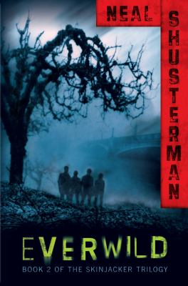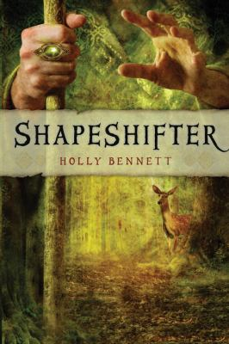

**Shapeshifter,** by Holly Bennett

In order to escape the sorcerer who wants to control her gift of song, Sive must transform herself into a deer, leave the Otherworld and find refuge in Eire, the land of mortals. This is a boldly written, tightly plotted, and hard-edged novel

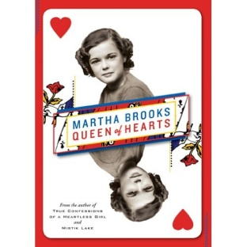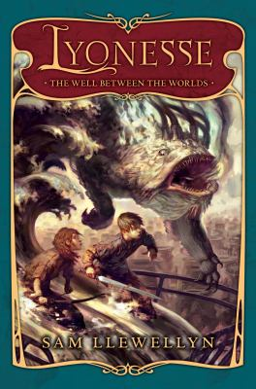

**Well Between the Worlds, by Sam Llewellyn**

Eleven-year-old Idris Limpet, living with his family in the once noble but now evil and corrupt island country of Lyonesse, finds his life taking a dramatic turn when, after a near-drowning incident, he is accused of being allied to the feared sea monsters and is rescued from a death sentence by a mysterious and fearsome stranger.

**Queen of Hearts,** by Martha Brooks

It's 1941, and Canada is two years into World War II. Meanwhile, in rural Manitoba, fifteen-year-old Marie-Claire Cote begins a war of her own as she and her brother and sister, all stricken with tuberculosis, are taken by their anguished parents to "chase the cure" at nearby Pembina Hills Sanatorium.

**Boom!, by Mark Haddon**

From the moment that Jim and his best friend Charlie bug the staff room and overhear two of their teachers speaking to each other in a secret language, they know there's an adventure on its way. There really is an adventure on its way. A nuclear-powered, one hundred-ton adventure with reclining seats and a buffet car. And as it gathers speed and begins to spin out of control, it can only end in one way ...with a BOOM.

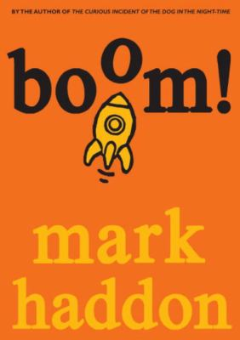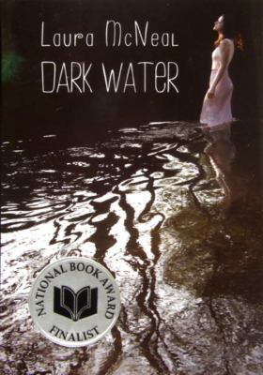

**Dark Water, by Laura McNeil**

Living in a cottage on her uncle's southern California avocado ranch since her parent's messy divorce, fifteen-year-old Pearl Dewitt meets and falls in love with an illegal migrant worker, and is trapped with him when wildfires approach his makeshift forest home.

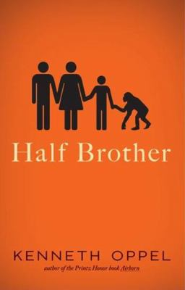

**Half Brother, by Kenneth Oppel**

In this humorous novel, when a renowned Canadian behavioral psychologist pursues his latest research project--an experiment to determine whether chimpanzees can acquire advanced language skills--he brings home a baby chimp named Zan and asks his thirteen-year-old son to treat Zan like a little brother.

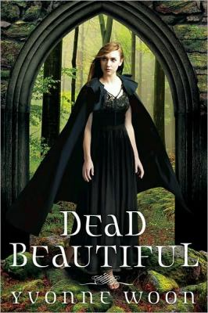

**Dead Beautiful, by Yvonne Woon**

After her parents die under mysterious circumstances, sixteen-year-old Renee Winters is sent from California to an old-fashioned boarding school in Maine, where she meets a fellow student to whom she seems strangely connected.

**Heist Society, by Ally Carter**

In this gripping crime novel, a group of teenagers uses their combined talents to re-steal several priceless paintings and save fifteen-year-old Kat Bishop's father, himself an international art thief, from a vengeful collector.

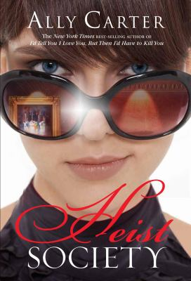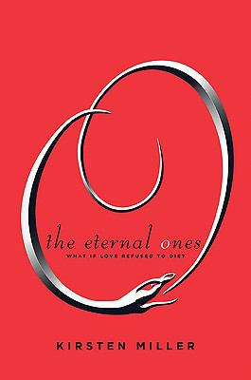

**Eternal Ones, by Kirsten Miller**

Seventeen-year-old Haven Moore leaves East Tennessee to attend the Fashion Institute of Technology in New York City, where she meets playboy Iain Morrow, whose fate may be tied to hers through a series of past lives.

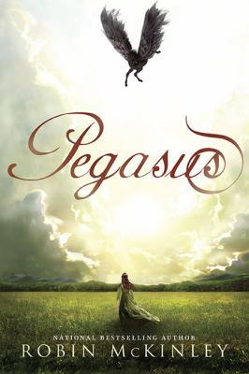

**Pegasus, by Robin McKinley**

Because of a thousand-year-old alliance between humans and pegasi, Princess Sylvi is ceremonially bound to Ebon, her own pegasus, on her twelfth birthday, but the closeness of their bond becomes a threat to the status quo and possibly to the safety of their two nations.

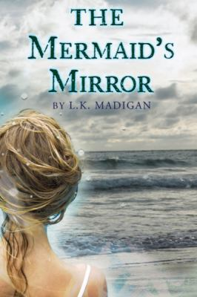

**Mermaid’s Mirror,** by L. K. Madigan

Lena, almost sixteen, has always felt drawn to the waters of San Francisco Bay despite the fears of her father, a former surfer, but after she glimpses a beautiful woman with a tail, nothing can keep Lena from seeking the mermaid in the dangerous waves at Magic Crescent Cove.

**Trash, by Andy Mulligan**

This mystery novel is set in an unnamed third world country, where fourteen-year-olds Raphael and Gardo team up with a younger boy, Rat, to figure out the mysteries surrounding a bag Raphael finds during their daily life of sorting through trash in a third-world country's dump.

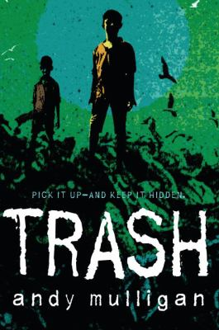

**Crave, by Laura Burns**

In this suspenseful story, seventeen-year-old Shay, having suffered from a rare blood disorder her entire life, starts receiving blood transfusion from her step-father who is a physician, and, when she begins to see visions through the eyes of a vampire she decides to investigate, discovering a teenage vampire locked up in the doctor's office who she becomes attached to and set free, only to be kidnapped by the creature who wants revenge.

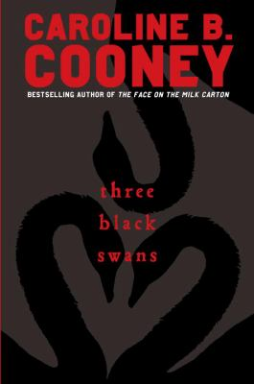

**Three Black Swans, by Caroline Cooney**

In this riveting, heartrending the truth changes the lives of three families—as the bonds of blood must withstand the strains of long-hidden secrets that are at last revealed. When sixteen-year-old Missy Vianello decides to try to convince her classmates that her cousin Claire is really her long-lost identical twin, she has no idea that the results of her prank will be so life-changing.

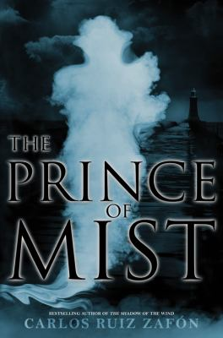

**Prince of the Mist, Carlos Ruiz Zafon**

In 1943, in a seaside town where their family has gone to be safe from war, thirteen-year-old Max Carver and sister, fifteen-year-old Alicia, with new friend Roland, face off against an evil magician who is striving to complete a bargain made before he died. This is a beautifully written story of magic and horror.

**Girl Stolen, by April Henry**

In this suspenseful crime novel, when an impulsive carjacking turns into a kidnapping, Griffin, a high school dropout, finds himself more in sympathy with his wealthy, blind victim, sixteen-year-old Cheyenne, than with his greedy father.

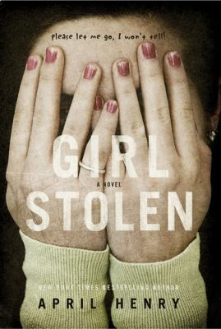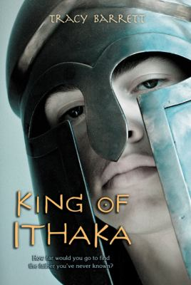

**King of Ithaka, by Tracy Barrett**

When sixteen-year-old Telemachos and his two best friends, one a centaur, leave their life of privilege to undertake a quest to find Telemachos's father Odysseus, they learn much along the way about what it means to be a man and a king. This is a fast-paced mythical adventure.

**The Grimm Legacy, by Polly Shulman**

In this magical fantacy adventure, New York high school student Elizabeth gets an after-school job as a page at the "New-York Circulating Material Repository," and when she gains coveted access to its Grimm Collection of magical objects, she and the other pages are drawn into a series of frightening adventures involving mythical creatures and stolen goods.

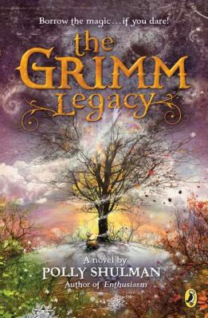

**The Unidentified, by Rae Mariz**

In a futuristic alternative school set in a shopping mall where video game-playing students are observed and used by corporate sponsors for market research, Katey "Kid" Dade struggles to figure out where she fits in and whether she even wants to. This funny, sharp, and thought-provoking novel will leave you wanting more.

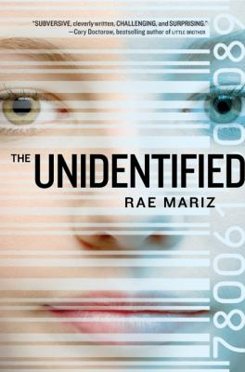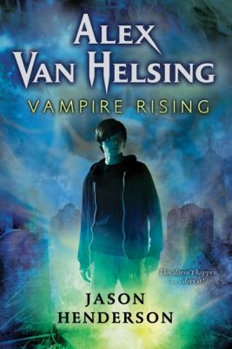

**Vampire Rising, by Jason Henderson**

At a boarding school in Switzerland, fourteen-year-old Alex Van Helsing learns that vampires are real, that he has a natural ability to sense them, and that an agency called the Polidorium has been helping his family fight them since 1821. Now they want to to train Alex in the tricks of the trade.. . if he can survive the zombies, bullets, and fangs heading his way! This is an action-packed fantasy adventure.

**Bruiser, by Neal Shusterman**

Inexplicable events start to occur when sixteen-year-old twins Tennyson and Brontë befriend a troubled and misunderstood outcast, aptly nicknamed Bruiser, and his little brother, Cody. This is an eloquent and thoughtful story that will most certainly leave its mark.

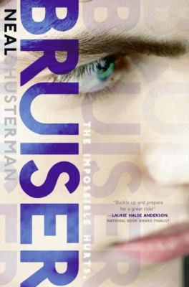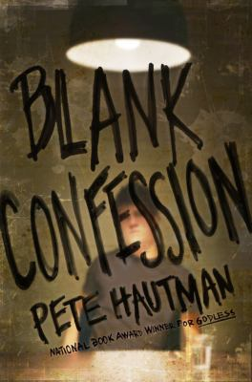

**Blank Confession, by Pete Hautman**

Shayne Blank is the new kid in tow-but that doesn't stop him from getting into a lot of trouble very quickly. The other kids don't understand him. He's not afraid of anything. He seems too smart. And his background doesn't add up. But when he walks into the police department to confess to a murder, it quickly becomes apparent that nothing is as it seems. There's more to Shayne-and his story-than meets the eye.

**Toads and Diamonds, by Heather Tomlinson**

A retelling of the Perrault fairy tale set in pre-colonial India, in which two stepsisters receive gifts from a goddess and each walks her own path to find her gift's purpose, discovering romance along the way.

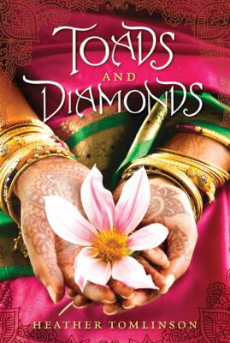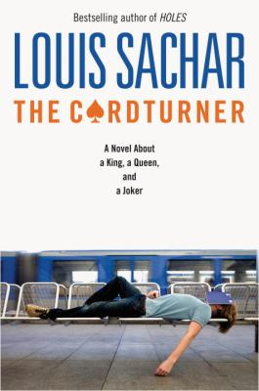

**The Card Turner,** by Louis Sachar

The summer after junior year of high school looks bleak for Alton Richards. His girlfriend has dumped him to hook up with his best friend. He has no money and no job. His parents insist that he drive his great-uncle Lester to his bridge club four times a week and be his cardturner -- whatever that means. As the summer goes on, he struggles to figure out what it all means, and ultimately to figure out the meaning of his own life.

**Heart to Heart, by Lurlene McDaniel**

Relates the complicated friendship of a teenaged girl, her best friend, her best friend's boyfriend, and a young heart transplant recipient. When the worlds of these three girls and their families intersect, lives are changed in ways never imagined.

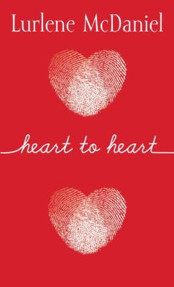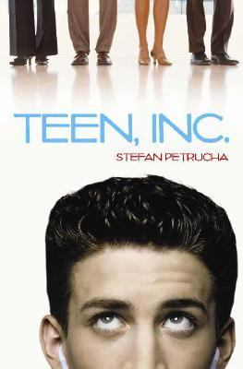

**Teen, Inc. by Stefan Petrucha**

Fourteen-year-old Jaiden has been raised by NECorp. since his parents were killed when he was a baby, so when he discovers that the corporation has been lying about producing illegal levels of mercury emissions, he and his two friends decide to try to do something about it. Witty and provocative, this novel has both daring characters and a heady plot.



**Hate List, by Jennifer Brown**

Sixteen-year-old Valerie, whose boyfriend Nick committed a school shooting at the end of their junior year, struggles to cope with integrating herself back into high school life, unsure herself whether she was a hero or a villain. Shot trying to stop him, Valerie inadvertently saved the life of a classmate, but was implicated in the shootings because of the list she helped create. A list of people and things she and Nick hated. The list he used to pick his targets.

**Nothing,** by Janne Teller

When thirteen-year-old Pierre Anthon leaves school to sit in a plum tree and train for becoming part of nothing, his seventh grade classmates set out on a desperate quest for the meaning of life.

**Nick of Time, by Ted Bell**

Nick, Kate and their father are engaged in a desperate war of espionage with the German U-boat fleets that are circling the islands prior to invasion. The information they provide daily to Winston Churchill is vital as he tries to warn England of the Nazi invasion. In a surprising twist, Nick discovers an old sea chest sent to him by his ancestor, Captain Nicholas McIver of the Royal Navy and returns to the year 1805 via a time machine and help save Captain McIver from Captain Billy Blood.

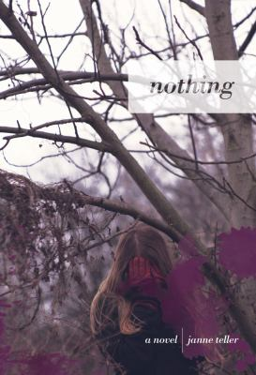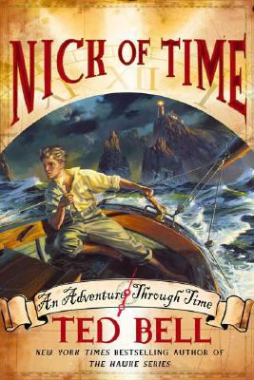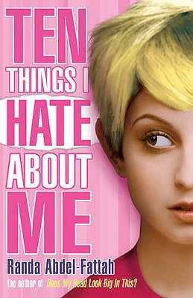

**Devil’s Breath, by David Gilman**

When fifteen-year-old Max Gordon's environmentalist-adventurer father goes missing while working in Namibia and Max becomes the target of a would-be assassin at his school in England, he decides he must follow his father to Africa and find him before they both are killed in this fast-paced adventure.

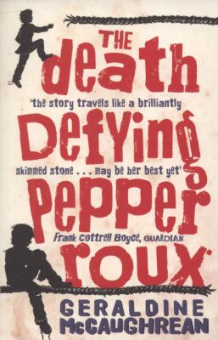

**Ten Things I Hate About Me,** by Randa Abdel-Fattah

For the past three years Jamie has hidden her Lebanese background from everyone at school. It's only with her email friend John that she can really be herself. But now things are getting complicated: the most popular boy in school is interested in her, but there's no way he would be if he knew the truth. Then there's Timothy, the school loner, who for some reason Jamie just can't stop thinking about. As for John, he seems to have a pretty big secret of his own.

**The Death-Defying Pepper Roux,** by Geraldine McCaughrean

When Pepper Roux was born his aunt foretold that he would not live past 14 years of age. So when Pepper wakes up on his 14th birthday he knows this will be the day that he'll die. But as the day wears on, and Pepper finds himself still alive, he decides to set off to sea in an attempt to try and avoid death for as long as possible. This riot of a story is a wonderful adventure, and Pepper is an unforgettable character who stays with you long after his story has been told.