HOW TO MAKE A PREZI
Go to: https://prezi.com/
- Where you see “For Individuals and Students,” click “Go to Prezi.”
- 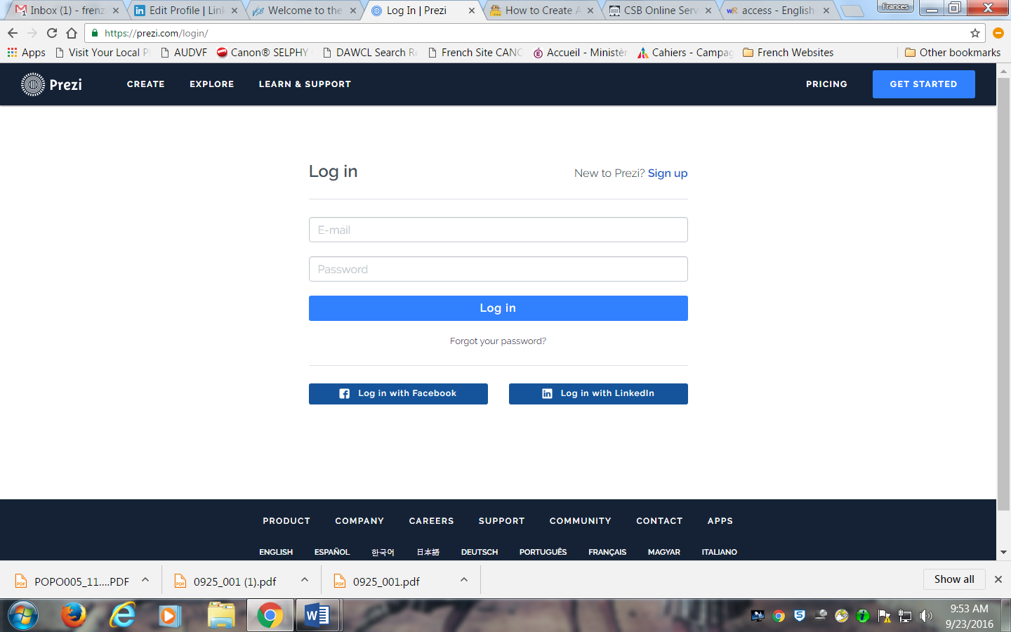
- Where it says, “New to Prezi,” choose Sign-up. Put in your email and choose a password. We will choose the Public Account option where everything is free.
- Now click “Learn and Support.” We will view together, “Simple Steps for a Great Prezi.”
- 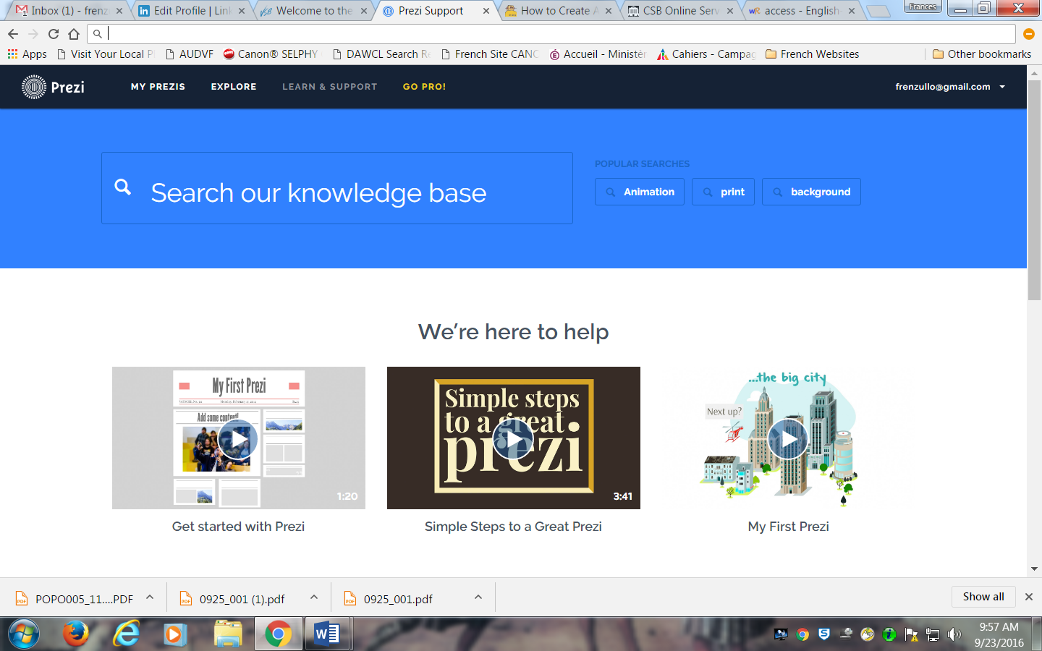
- https://youtu.be/fmgF-dLXv58
- https://youtu.be/eWns0P_z200
After viewing 2 Tutorials begin experimenting with your Prezi by choosing a template, inserting text and images and then clicking on Present. Practice makes perfect. Good Luck!

