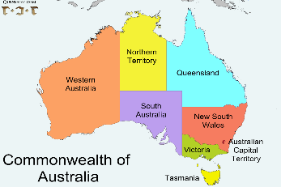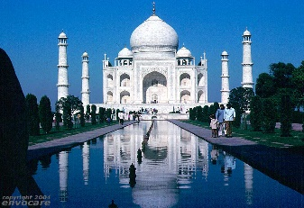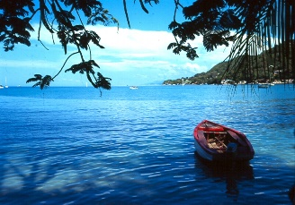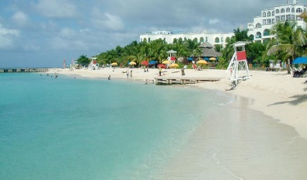
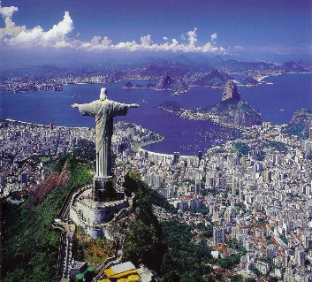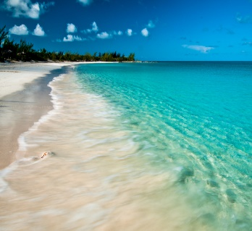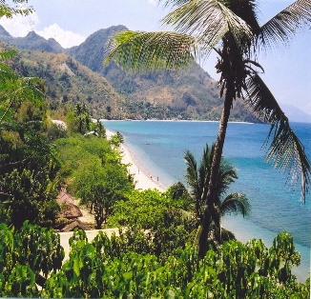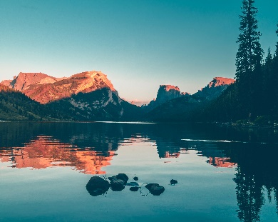
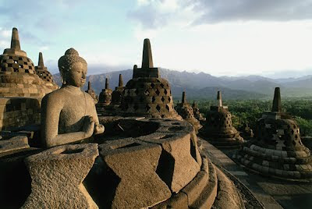
Name:
Country chosen:
Colonized by:
1. Who was already in your country when the new settlers arrived? For how long?

2. What languages and/or dialects were spoken at that time?

3. Describe these new settlers (those that colonized your chosen country).

4. Was it a hostile or peaceful takeover/unification? Describe what it looked like.

5. How did life change for the people who were already living there.
Before colonization | After colonization
Language
Food
Government
Culture
Religion
Customs/Traditions/Rituals
Population
Other

