PASSION PROJECT

“The illiterate of the 21st century will not be those who cannot read and write, but those who cannot learn, unlearn, and relearn.”
Alvin Toffler
Passion exploration and streamlining…….. Be brave and share, we’re here to help.
Library Notetaking Research Sheet-How to find what you’re looking for. Please consult the Library website for helpful links under Teachers Projects/Capstone at http://www.vantechlibrary.org/
My Passion
Character-istics of my passion

Skills and knowledge

required to develop my passion

Most rewarding aspects of my passion

Most challenging aspects of my passion

Professions
Jobs related to my passion

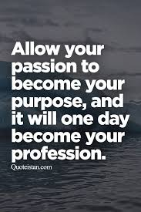
Employ-
ment
Outlook
More or Fewer Jobs?/Speed of Openings/
Trends affecting Openings/
Artificial Intelligence?
Full-Time?, Part-Time?
Contract?, Temporary?
Benefits?

Finance
Grants/
bursaries/
scholarships to develop my passion
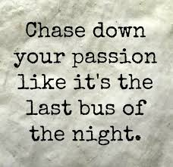

Education

Training/
Education
Workshops
Seminars
Apprenticeship
Courses

Costs
(tuition/travel/supplies/
materials)

Websites
to find more information and contacts

Places to visit
to develop my passion (studios, VPL-inspiration lab, libraries, community centres, senior homes, police station)

Reaching Out
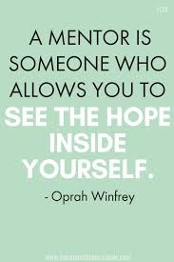Find someone to email, volunteer with or interview.
An opening letter or message you might write. (not text)

EXTRA NOTES :

